**Graph Analytics**

**Modeling Chat Data using a Graph Data Model**

(Describe the graph model for chats in a few sentences. Try to be clear and complete.)

**Creation of the Graph Database for Chats**

Describe the steps you took for creating the graph database. As part of these steps

1. Write the schema of the 6 CSV files
2. Explain the loading process and include a sample LOAD command
3. Present a screenshot of some part of the graph you have generated. The graphs must include clearly visible examples of most node and edge types. Below are two acceptable examples. The first example is rendered in the default Neo4j distribution, the second has had some nodes moved to expose the edges more clearly. Both include examples of most node and edge types.

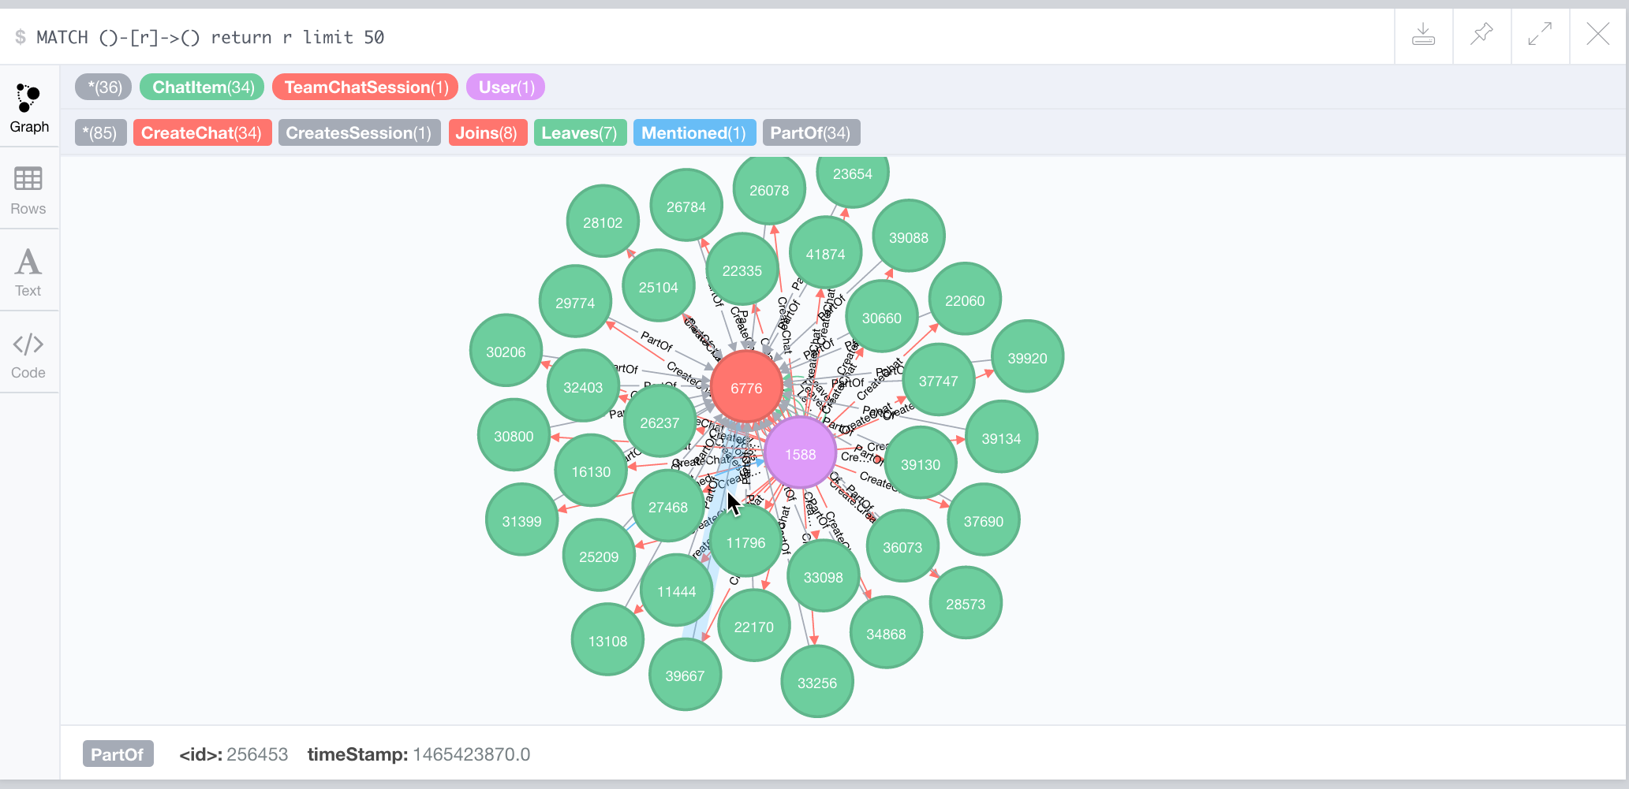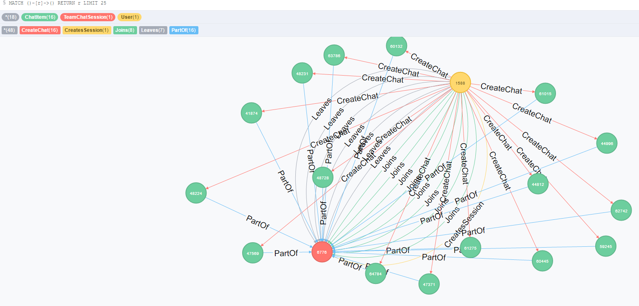

**Finding the longest conversation chain and its participants**

Report the results including the length of the conversation (path length) and how many unique users were part of the conversation chain. Describe your steps. Write the query that produces the correct answer.

**Analyzing the relationship between top 10 chattiest users and top 10 chattiest teams**

Describe your steps from Question 2. In the process, create the following two tables. You only need to include the top 3 for each table. Identify and report whether any of the chattiest users were part of any of the chattiest teams.

**Chattiest Users**

| **Users** | **Number of Chats** |
| --- | --- |
|  |  |
|  |  |
|  |  |

**Chattiest Teams**

| **Teams** | **Number of Chats** |
| --- | --- |
|  |  |
|  |  |
|  |  |

Finally, present your answer, i.e. whether or not any of the chattiest users are part of any of the chattiest teams.

**How Active Are Groups of Users?**

Describe your steps for performing this analysis. Be as clear, concise, and as brief as possible. Finally, report the top 3 most active users in the table below.

**Most Active Users (based on Cluster Coefficients)**

| **User ID** | **Coefficient** |
| --- | --- |
|  |  |
|  |  |
|  |  |